

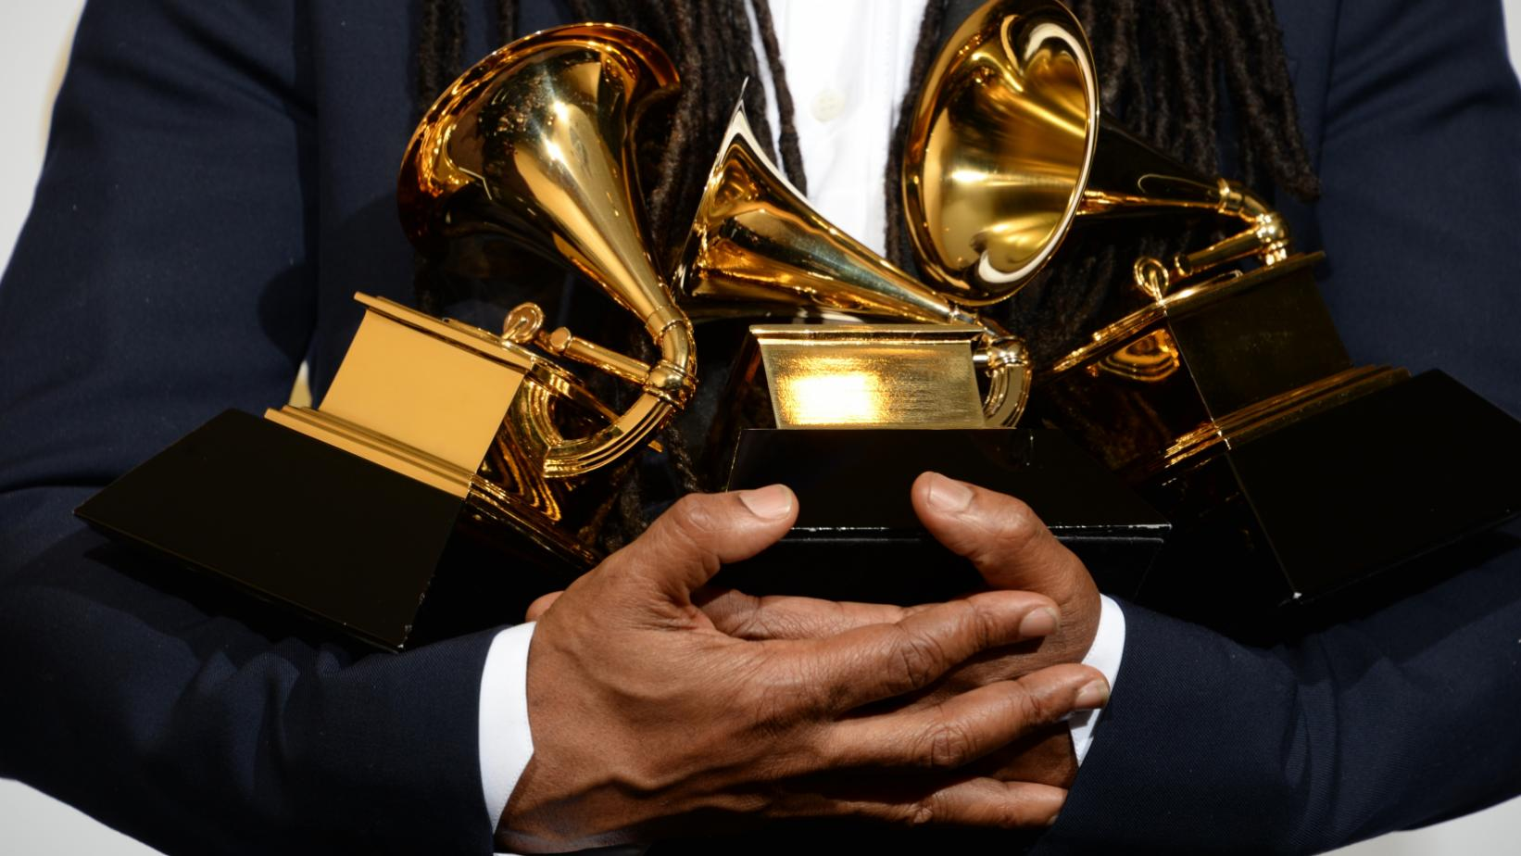

(Joe Klamar,AFP, Getty Images)[1]

**Is the GRAMMYs voting system biased?**

**02.137DH: Introduction to Digital Humanities**

Cornelia Ho Xin Ning (1004678)

Samuel Sim Wei Xuan (1004657)

Tan Yew Siew (1004665)

**Table of Contents**

Introduction 1

Background 1

Research Questions 2

Hypothesis 2

Methodology 3

Main Results and Analysis 5

Assumptions and Limitations 8

**Data Collection** 8

**Research Questions** 8

Conclusion 9

Bibliography 10

Appendix 11

**Annex A** 11

**Annex B** 12

**Annex C** 13

# **Introduction**

“The Weeknd Responds to 2021 Grammys Snub: ‘The Grammys Remain Corrupt’” - Rolling Stones. This was only one of the many headlines written about the 63rd Annual GRAMMYs’ nomination snub of Canadian singer-songwriter, the Weeknd. The Weeknd’s album, After Hours, and song, Blinding Lights, received no nominations at the 2021 GRAMMYs, despite its huge commercial success with 1.8 billion and 882 million streams respectively (Vozick-Levinson, 2020). This resurfaced the issue of corruption within the GRAMMYs voting system, which we will take a closer look at in this paper.

# **Background**

The voting process of the GRAMMYs has always been one that is shrouded in mystery. With questions targeted towards the transparency of the criteria of how nominees and winners are chosen. This lack of transparency has caused the GRAMMYs to be the center of controversy in recent years. Just last year, the former CEO of the GRAMMYs, Deborah Dugan, was fired just a few weeks before the 62nd annual award show. According to the Rolling Stones, Dugan mentioned the reason for her dismissal was due to her raising the issue of the undemocratic voting system of the private review committee to the organisation’s board. This private review committee is a group of members, whose identities remain undisclosed, that review the 20 nominees chosen by the voting members and decide on the final eight nominees for each category (Hissong & Wang, 2020). The strict eligibility criteria do provide voting members with a certain level of credibility (McKinney, 2016). In the same vein, it is this private group of members that raise the question of whether the GRAMMYs is biased in deciding its winners and nominees. The GRAMMYs, however, claim that the opaqueness they adopt in the voting process helps to prevent fraud. Nevertheless, many others, including Dugan, also claim that this opaqueness precisely is what enables the process to be corrupt - due to biases stemming from personal or business relationships (Hissong & Wang, 2020).

# **Research Questions**

Our group aims to find out whether the GRAMMYs considers audio features and popularity of the tracks when choosing its winners and nominees. Secondly, our group also wants to give insights into possible racial or gender discrimination of the artists.

# **Hypothesis**

At the GRAMMYs, “Song of the Year is awarded to the songwriter who composed the lyrics and/or the melodies to the song based on a track of an album. Whereas, Record of the Year is awarded to the performing artist, the producers, the sound engineers, the master engineer, and the sound mixer based on a track of an album” (McKinney & Trolio, 2020). The difference between them is that Song of the Year focuses on the composing of a song while Record of the Year involves the making of the audio features of a song. The nomination for the GRAMMYs must also fulfill the criteria of being commercially released and sold in the United States (McKinney, 2016). For Spotify however, the most streamed songs globally are entirely based on streaming counts from all regions.

For our first research question, we will be performing an analysis based on the Record of the Year instead of the Song of the Year. We feel that the production and audio features of a song are the main deciding factor for a nomination at the GRAMMYs and also to be a top streaming song on Spotify. Thus, we want to see whether the audio features and popularity of the songs are indeed factored into the selection of the GRAMMYs song nominations, using the audio features of the top streaming songs from Spotify as a base of comparison.

For our second research question, we aim to shed light on possible racial and gender discrimination of the nominated artists. We will be instead comparing the artists from the GRAMMYs Album of the Year and the artists from the globally most-streamed Albums of Spotify. We believe that the Album describes an artist better compared to a single track.

# **Methodology**

The advent of inexpensive streaming services meant that many people have been switching towards using music streaming platforms. Among the list of music streaming services, in 2019 Spotify topped the list as the leading streaming service, crippling competitors such as Apple Music which fell behind by more than half the subscriber counts of Spotify (Armstrong, 2020). Therefore, we chose Spotify as our subject of comparison. Furthermore, their open-sourced web-API developer allows us to easily tap into their analysis of tracks.

First, we compiled a list of song nominees for the GRAMMYs Award Record of the Year, and the Spotify top streamed songs globally (Annex A), from a list of sources found in Annex B. Since the controversy was only recently, the list includes songs from 2016 to 2020. Secondly, using the Spotify Web API, we extracted the unique song IDs for every listed song. Moving on, for each track, we extracted 11 audio features of a song. The 11 features include danceability, energy, key, loudness, mode, speechiness, acousticness, instrumentalness, liveness, valence, and tempo. To visualise this high dimensionality data, a parallel coordinates plot is being used. Each line of the plot would correspond to a specific track while each column represents a feature of the song. Then, we draw specific ranges for the values of each column that best captures the overall shape of the plot. From there based on the number of Grammy Songs and Spotify Songs captured by the overall general shape, we can determine which platform has more outliers. This would help provide insight into the possible differences between the song nominations for Grammy Record of the Year compared to the Spotify globally most streamed songs.

Secondly, we compiled a list of the artists who have been nominated for the Album of the Year and the artists of the globally most-streamed Album of Spotify. Now, instead of a parallel coordinate plot, an alluvial plot would be used. The columns of the plot would include categorical features such as gender and race. For the categories of race, we followed the United States Department of Education (USED) Guidance on Maintaining, Collecting, and Reporting Race and Ethnicity Data (United States Department of Education, 2007), and for the gender, we assumed biological sex. For the sake of simplicity, we excluded groups or bands nominees from the analysis. For race, if an artist was a mix of several races, we took the one with a larger percentage to classify them. However, since there was only one Latino-Asian and one African American-Asian artist that had an equal weightage in both races, we chose to omit the Asian and go with the majority of the categories for simplicity sake. From the plot, we can compare the distribution of both features among the artists from both platforms.

The code we used can be found in the following URL:

[*https://colab.research.google.com/drive/1G-jyEnjmDRh3AcINXBMOd20hZUNAsHHF?usp=sharing#scrollTo=YcWRUOkaAPpE*](https://colab.research.google.com/drive/1G-jyEnjmDRh3AcINXBMOd20hZUNAsHHF?usp=sharing#scrollTo=YcWRUOkaAPpE)

# **Main Results and Analysis**

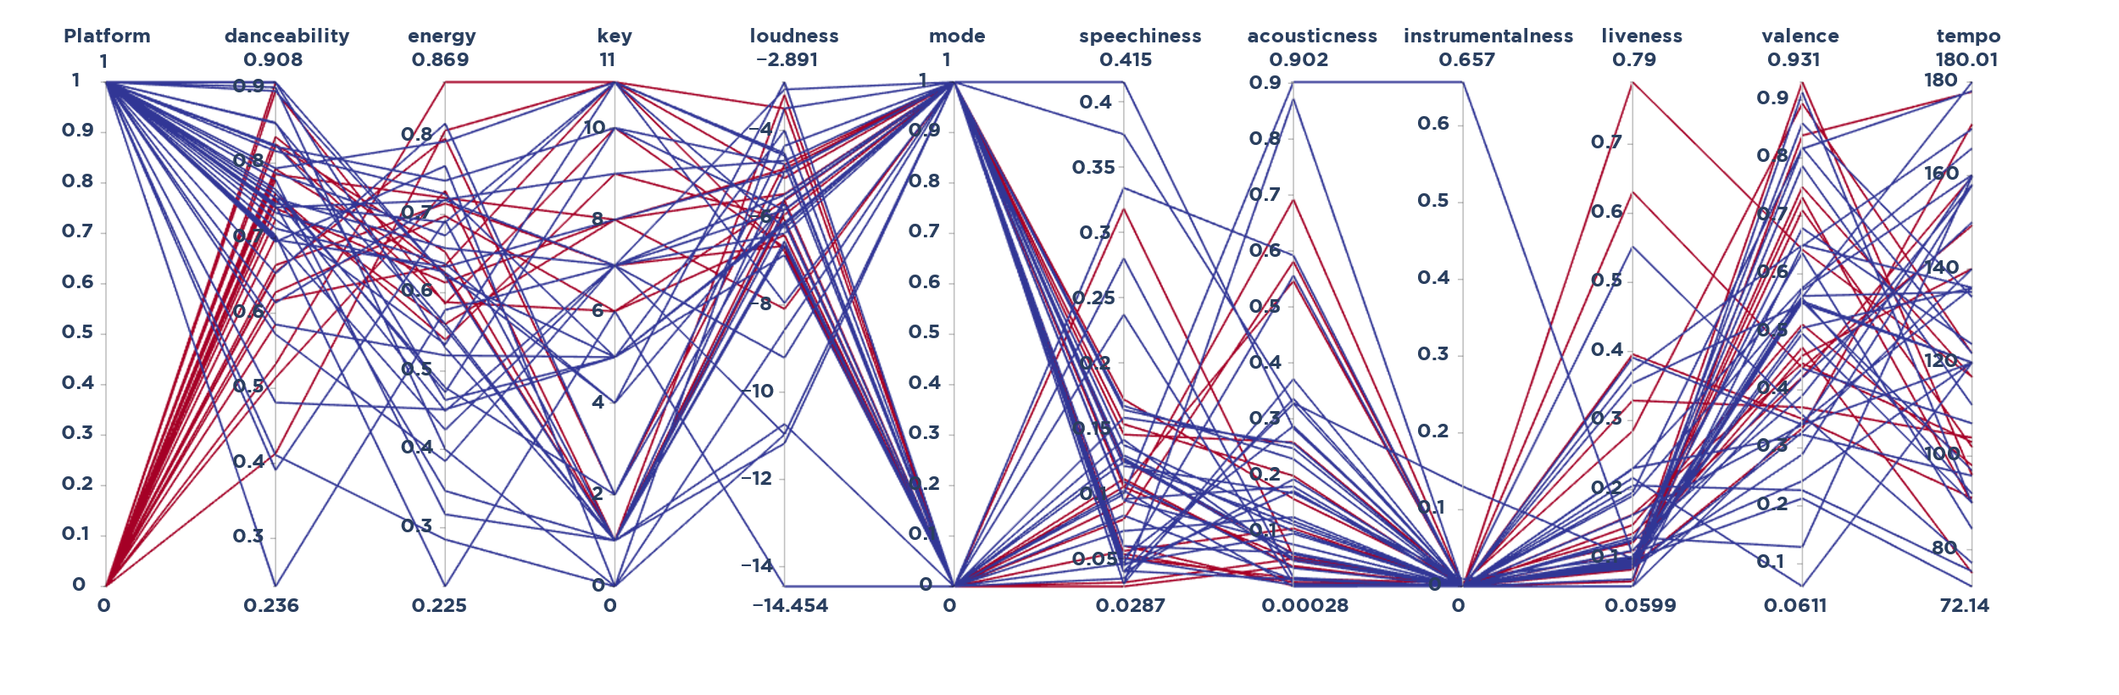

*Figure 1a. Parallel coordinate plot for the nominated songs from GRAMMYs and the songs from Spotify*

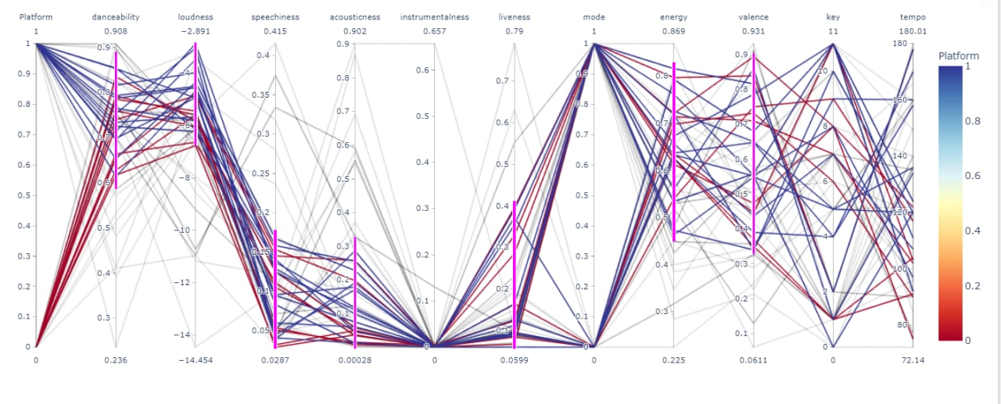

*Figure 1b. General trend of the parallel coordinate plot in Figure 1a*

*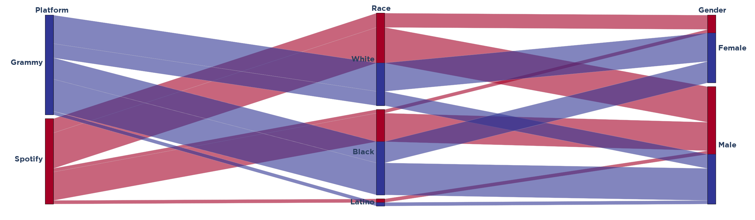Figure 2. Alluvial Plot of Platform, Race and Gender*

For all figures, the blue lines or shapes represent artists and songs from GRAMMYs while the red lines or shapes represent the artists and songs from Spotify. In *Figure 1a*, each line represents a track, and the columns represent the different audio features of each track. From this graph, we can spot the general shape of all tracks.

Using this general shape, we plot specific ranges (pink bar) of each audio feature where most of the tracks lie within (*Figure 1b*). This presents a cleaner representation of the data. From this graph, to spot the outliers, we look at the 1st column, which represents which platform the track is. We can see that more of the songs from GRAMMYs are excluded, and most of Spotify songs are included. This means that audio features which correlate strongly with streaming count and popularity of songs based on Spotify are not a significant consideration in the nomination of songs for the GRAMMYs Song of the Year Award. Hence our initial hypothesis that song popularity and audio features play a significant role in the nomination of songs is false statistically. Humanistically speaking, this provides insight to the controversy that perhaps indeed biases in the nomination of songs do exist as audio features and popularity can be removed from the equation. Therefore, the selection of song nominees could be based on qualitative attributes instead of the quantitative ones we have studied here.

Next, we will look at *Figure 2*, to address our second research question and provide further insights into the issue of racial and gender biasness. Looking at the race column, we can see that the size of the White (White Americans) and Black (African American) categories are relatively the same. Even though the others are relatively small, this is probably due to the eligibility of GRAMMYs nominations having to be distributed in the United States and the majority of globally acclaimed artists coming from the West. Moving on to the gender column, the same can be said about Male and Female categories. However, we also can see that, for the artists who were nominated for the GRAMMYs compared to Spotify, a larger portion were female artists. This could suggest that the panels of judges for the GRAMMYs are pushing for female empowerment in the music industry. In a nutshell, statistically speaking, the data does not show any strong racial or gender discrimination. Therefore, in light of the controversy, perhaps the biasness could be directed towards certain artists instead of such a broad level of discrimination like race. After all, it is still suspicious as to why the number one most streamed song on Spotify in 2020, Blinding Lights by The Weeknd, was not nominated. Interestingly, he Weeknd was nominated in previous years for the Album of the Year Award multiple times. As aforementioned, the private review committee is claimed not to vote democratically as well, which raises many questions of their credibility. With our current findings, we can conclude that the GRAMMYs are not significantly biased towards any race or gender but are still unable to draw a definitive answer as to whether the GRAMMYs are biased in any other form.

# **Assumptions and Limitations**

## **Data Collection**

One of the limitations we faced when collecting data was that the top streaming songs, we compiled for each year from Spotify were for the number of streams within that year itself. Whereas the nominees for the GRAMMYs could only be chosen within the time frame set by the National Academy of Recording Arts and Sciences, which is somewhere between the end of the previous year and the end of the current year. Thus, even though our results did show a good correlation, it does not mean that it was entirely accurate. In the future, we will instead use data from top streaming songs on Spotify from the same period set like the one from the GRAMMYs.

Another limitation we faced was that the data we used in comparison with the GRAMMYs was only obtained from the Spotify API database. Although, as previously mentioned, the Spotify database will serve as a reasonable estimate for comparison, it still does not give us the complete picture as there are many other streaming and non-streaming platforms where songs are being listened. Therefore, in the future, we would expand our object of comparison to provide a more conclusive and accurate result.

## **Research Questions**

For the first research question, we used Record of the Year as a comparison to the top streaming Spotify songs, as mentioned above. However, the reason for a top streaming Spotify song could not only be associated with the audio features of a song, but also the lyrics and composition of the song. This is why in the future; we would also compare the Song of the Year to the top streaming Spotify songs and see whether the results match or if there would be any other trends that surfaced.

For the second research question, we used albums as a basis of comparison to determine whether the artists and winners were chosen based on racial and gender biases held by the Academy. However, this might not be accurate as the success of an album cannot fully represent the biases towards and against individual artists and is only one factor out of many being considered. For instance, a particular album might be popular due to the songs in the Album and not the profile of the artist. Due to the limited categories found in the GRAMMYs, we can only work with modifying the dataset used in the comparison. Hence, in the future we could also look at the top streamed artists on Spotify for each year, to give us a better look at this issue.

# **Conclusion**

To put all this into context, even though our findings show no strong racial or gender discrimination in the voting process, we were still unable to find a trend or criteria on how exactly the GRAMMYs determine its winners and nominees. Thus, further research will need to be done to conclude whether the GRAMMYs voting system is biased in any other form.

# **Bibliography**

Vozick-Levinson, S. (2020, November 24). *The Weeknd Responds to 2021 Grammys Snub: ‘The Grammys Remain Corrupt’.* Rolling Stone. https://www.rollingstone.com/music/music-news/weeknd-grammys-snub-1094457/

Hissong, S. & Wang, A. X. (2020, February 13). *Inside the ‘Secret Committees’ That Quietly Run the Grammy Awards.* Rolling Stone. https://www.rollingstone.com/pro/features/grammy-awards-secret-committees-945532/

McKinney, K. (2016, February 15). *The Grammy voting process is completely ridiculous.* Vox. https://www.vox.com/2015/2/4/7976729/grammy-voting-process

McKinney, K. & Trolio, J. (2020, January 26). *The difference between the Grammys’ Song, Album, and Record of the Year categories, explained.* https://www.vox.com/2017/2/12/14593894/grammys-album-song-record-of-the-year-difference

Armstrong, M. (2020, February 13). *The world's most popular music streaming services.* Statista. https://www.statista.com/chart/20826/music-streaming-services-with-most-subscribers-global-fipp/

United States Department of Education (2007). *Guidance on Maintaining, Collecting, and Reporting Race and Ethnicity Data.* National Center for Education Statistics. https://nces.ed.gov/programs/handbook/data/pdf/Appendix_A.pdf

# **Appendix**

## **Annex A**

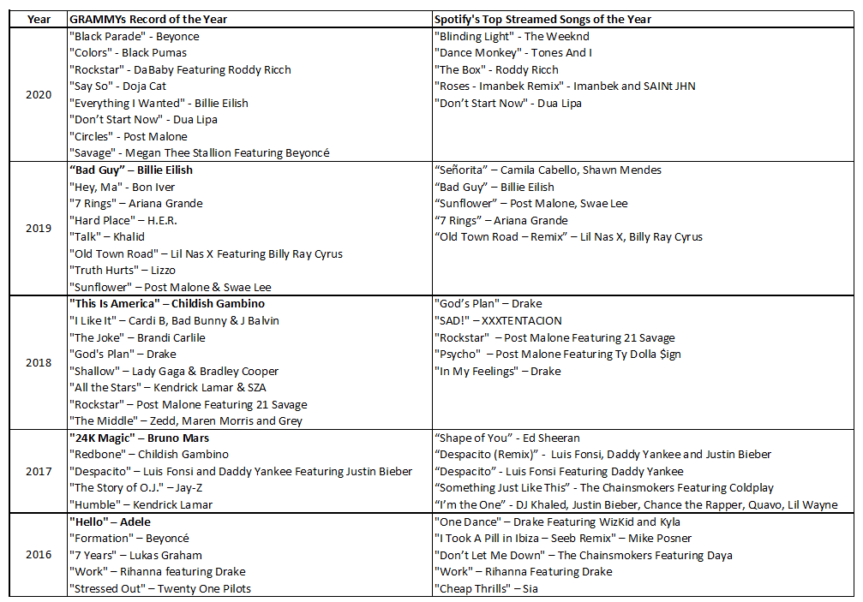

*Table 1. List of GRAMMYs Record of the Year and Spotify’s Top Streamed song of the Year*

The year stated in the *Table 1* is the year being assessed by the GRAMMYs and not the year the GRAMMYs was hosted in. For instance, the year 2020 means that the music being assessed is from the year 2020 but the GRAMMYs will be held in 2021. Winners of Record of the Year for the GRAMMYs in 2017 to 2020 are bolded. Results for the 2021 GRAMMYs are not out as of the submission of this paper.

## **Annex B**

***List of Spotify’s Top Streaming Songs and Albums***

* 2020: <https://newsroom.spotify.com/2020-12-01/the-trends-that-shaped-streaming-in-2020/>
* 2019: <https://newsroom.spotify.com/2019-12-03/the-top-songs-artists-playlists-and-podcasts-of-2019-and-the-last-decade/>
* 2018: <https://newsroom.spotify.com/2018-12-04/the-top-songs-artists-playlists-and-podcasts-of-2018/>
* 2017: <https://variety.com/2017/digital/news/ed-sheeran-rihanna-lead-spotifys-most-streamed-artists-of-2017-list-1202630294/>
* 2016: <https://www.harpersbazaar.com/culture/art-books-music/news/a19151/most-streamed-songs-spotify-2016/>

***List of GRAMMYs’ Record of the Year and Album of the Year***

* 2020: <https://www.grammy.com/grammys/awards/63rd-annual-grammy-awards-2020>
* 2019: <https://variety.com/2019/music/news/2020-grammys-nominations-list-1203410085/>
* 2018: <https://variety.com/2018/music/news/grammy-nominations-2019-complete-list-1203082934/>
* 2017: <https://variety.com/2017/music/news/2018-grammy-nominations-list-nominees-1202623881/>
* 2016: <https://variety.com/2016/music/news/grammy-nominations-2017-full-list-nominees-grammys-1201934204/>

## **Annex C**

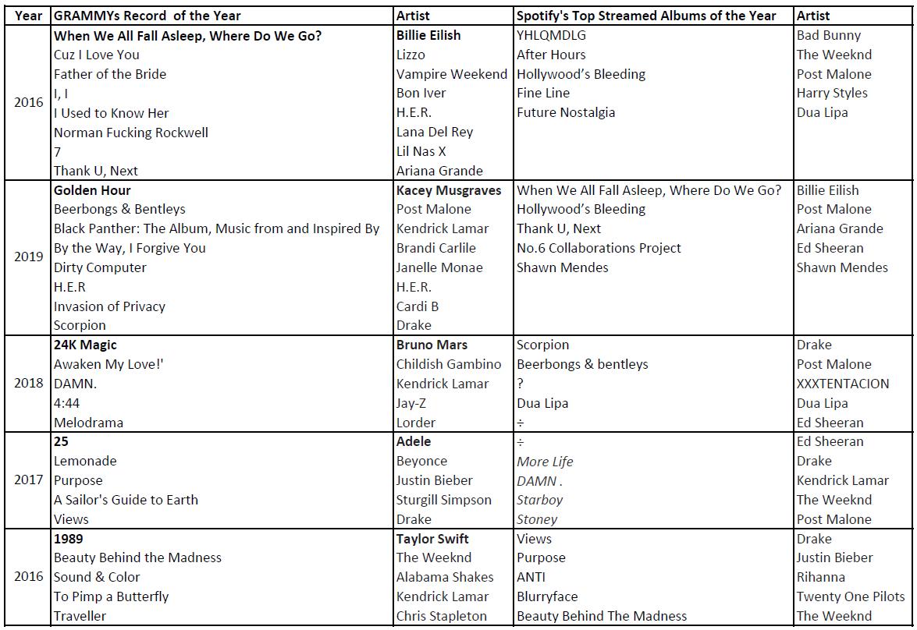

*Table 2. List of GRAMMYs Album of the Year and Spotify’s Top Streamed Album of the Year*

The year stated in the *Table 2* is the year being assessed by the GRAMMYs and not the year the GRAMMYs was hosted in. For instance, the year 2020 means that the music being assessed is from the year 2020 but the GRAMMYs will be held in 2021. Winners of Album of the Year for the GRAMMYs in 2017 to 2020 are bolded. Results for the 2021 GRAMMYs are not out as of the submission of this paper.

1. *https://www.grammy.com/grammys/news/doesn%E2%80%99t-feel-real-2021-grammy-nominees-celebrate-social-media*